**Discuss why it is necessary to use repetitive and selective statement. Use segment codes to demonstrate your understanding. Explain why you are choosing one of the following three statements in your code: a) for statement, b) while statement, c) do while statement. Provide examples.**

Repetitive and selective statements are necessary based on what type of work is expected to be conducted via the program that is being built.

An example of a selective statement would be the switch statement. Here, instead of using a series of if statements, the switch provides quick logical assessments to discern the appropriate choice, based on the input, and do the specified work necessary.

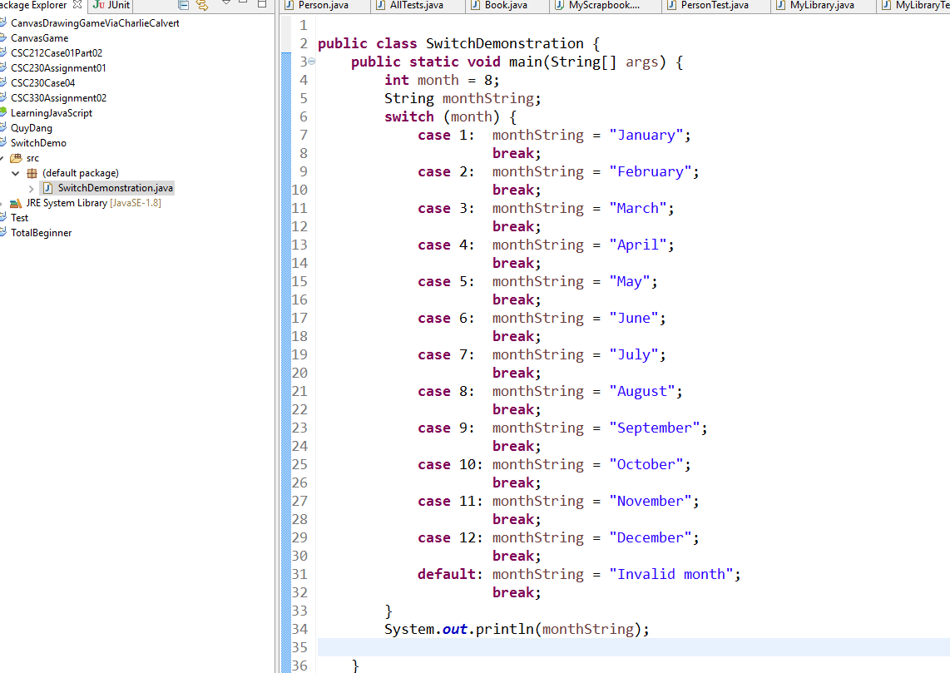

In the following getwords(Scanner input) function, the while loop is used to use a Scanner object to iterate over some String data and add unique vales to a TreeMap that will order the data alphabetically at it is built. The Map keeps a running total of all the keys, which are of String type, and does not allow for any erroneous characters. Only lower case alphabet characters are added to this Map. This is done until the Scanner no longer has any String data to read.

